Northumberland Schools’ Athletic Association
Founded | 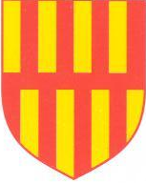 | 1949

Year ………………..
School Team Cross Country Championships 2015

Team – 2nd

Awarded to ………………………………………………………………………

of ………………………………………………….…………………….. School

Gateshead International Stadium

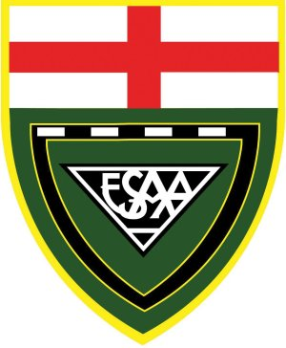

Secretary: S McAree Chairman: C Johnston Organiser: PJ Ponton

www.northumberlandschoolsathletics.co.uk
Northumberland Schools’ Athletic Association
Founded |  | 1949

Year ………………..
School Team Cross Country Championships 2015

Team – 3rd

Awarded to ………………………………………………………………………

of ………………………………………………….…………………….. School

Gateshead International Stadium

Secretary: S McAree Chairman: C Johnston Organiser: PJ Ponton

www.northumberlandschoolsathletics.co.uk

Northumberland Schools’ Athletic Association
Founded |  | 1949

Year ………………..
School Team Cross Country Championships 2015

Team – 4th

Awarded to ………………………………………………………………………

of ………………………………………………….…………………….. School

Gateshead International Stadium

Secretary: S McAree Chairman: C Johnston Organiser: PJ Ponton

www.northumberlandschoolsathletics.co.uk
Northumberland Schools’ Athletic Association
Founded |  | 1949

Year ………………..
School Team Cross Country Championships 2015

Team – 5th

Awarded to ………………………………………………………………………

of ………………………………………………….…………………….. School

Gateshead International Stadium

Secretary: S McAree Chairman: C Johnston Organiser: PJ Ponton

www.northumberlandschoolsathletics.co.uk

Northumberland Schools’ Athletic Association
Founded |  | 1949

Year ………………..
School Team Cross Country Championships 2015

Team – 6th

Awarded to ………………………………………………………………………

of ………………………………………………….…………………….. School

Gateshead International Stadium

Secretary: S McAree Chairman: C Johnston Organiser: PJ Ponton

www.northumberlandschoolsathletics.co.uk

