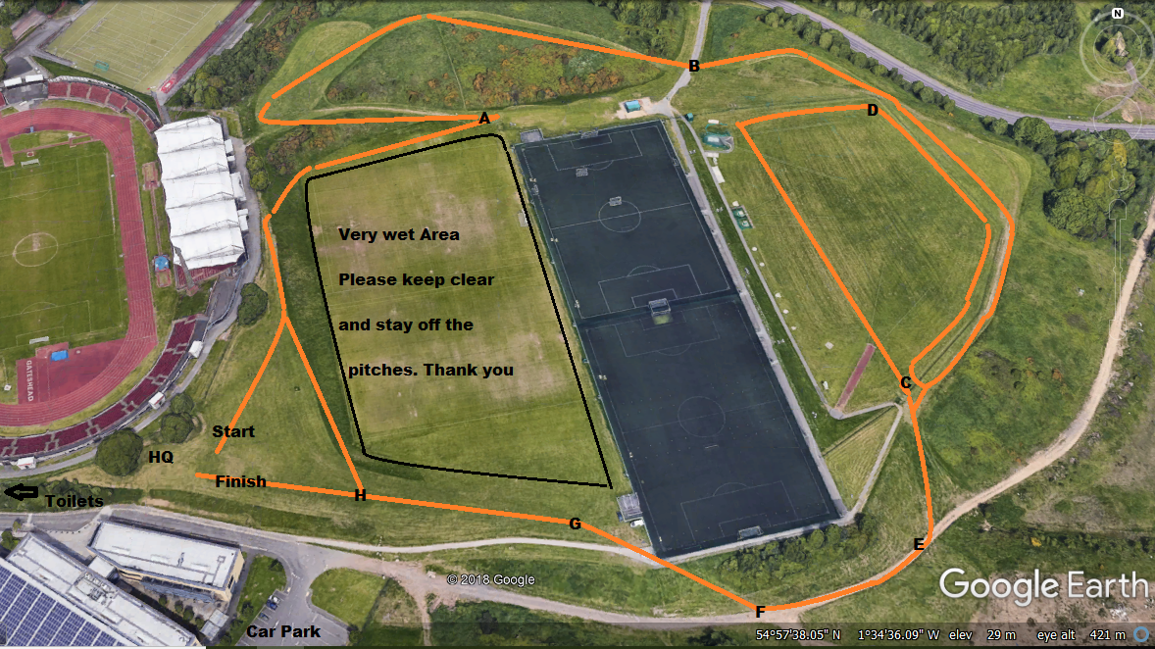

|  |  |  |  |  |  |  |  |  |
| --- | --- | --- | --- | --- | --- | --- | --- | --- |
| **Order** | **Category** | **PRIMARY & YEAR 7 CROSS COUNTRY 2019 - REVISED COURSES DUE TO WET WEATHER – suitable for spikes** | | | | | |  |
| **1** | Year 7 Girls | **Start** – A-B-C-E-F-G-H-A-B-C-E-F-G-H – **Finish** | **2120m** |  | **6** | Year 4 Boys | **Start** – A-B-C-E-F-G-H - **Finish** | **1110m** |
| **2** | Year 7 Boys | **Start** – A-B-C-E-F-G-H-A-B-C-D-C-E-F-G-H - **Finish** | **2630m** |  | **7** | Year 5 Girls | **Start –** A-B-C-D-C-E-F-G-H - **Finish** | **1510m** |
| **3** | Year 3 Girls | **Start** – A-B-C-E-F-G-H - **Finish** | **1110m** |  | **8** | Year 5 Boys | **Start –** A-B-C-D-C-E-F-G-H - **Finish** | **1510m** |
| **4** | Year 3 Boys | **Start** – A-B-C-E-F-G-H - **Finish** | **1110m** |  | **9** | Year 6 Girls | **Start –** A-B-C-D-C-E-F-G-H - **Finish** | **1510m** |
| **5** | Year 4 Girls | **Start** – A-B-C-E-F-G-H - **Finish** | **1110m** |  | **10** | Year 6 Boys | **Start –** A-B-C-D-C-E-F-G-H - **Finish** | **1510m** |