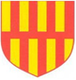 | Northumberland Schools’ Athletic Association  Cross Country Championships – Tuesday 20 January 2026  Temple Park Centre, South Shields. NE34 8QN
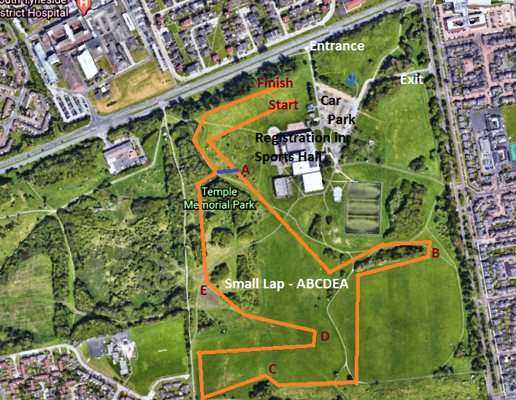 |  | 12:00 Minor Boys  1 Large Lap  Start - A-B-C-D-E - Finish  12:10 Senior Boys  2 Small Laps + 1 Large Lap  Start -A-B-C-D-E-A-B-C-D-E-A  B-C-D-E- Finish  12:15 Minor Girls  1 Large Lap  Start - A-B-C-D-E - Finish  12:35 Junior Girls  1 Large Lap  Start - A-B-C-D-E - Finish  12:50 Junior Boys  1 Small Lap + 1 Large Lap  Start -A-B-C-D-E-A-B-C-D-E- Finish  13:00 Inter & Senior Girls  1 Small Lap + 1 Large Lap  Start -A-B-C-D-E-A-B-C-D-E- Finish  13:15 Inter Boys  1 Small Lap + 1 Large Lap  Start -A-B-C-D-E-A-B-C-D-E- Finish

