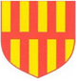 | Northumberland Schools’ Athletic Association  Cross Country Championships – Tuesday 16 January 2024  Temple Park Centre, South Shields. NE34 8QN
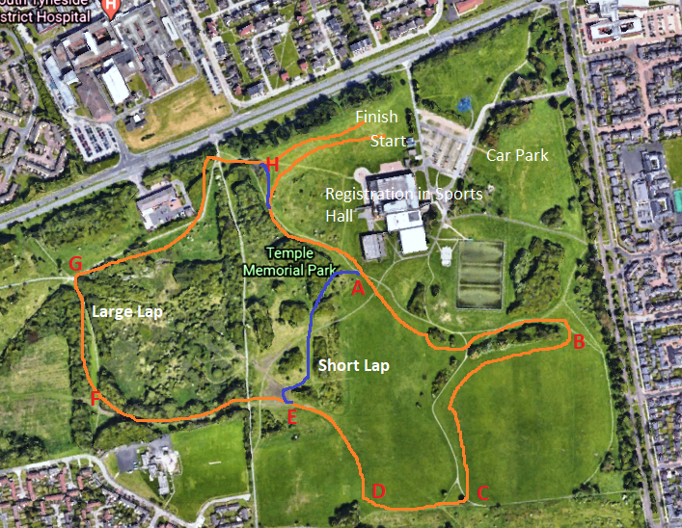 |  | 12:00 Minor Boys 2600m  1 Large Lap  Start - A-B-C-D-E-F-G-H -Finish  12:10 Senior Boys 6300m  Small Lap + 2 Large Laps  Start-A-B-C-D-E-A-B-C-D-E-F-G-H  -A-B-C-D-E-F-G-H-Finish  12:15 Minor Girls 2600m  1 Large Lap  Start - A-B-C-D-E-F-G-H -Finish  12:35 Junior Girls 2600m  1 Large Lap  Start - A-B-C-D-E-F-G-H -Finish  12:50 Junior Boys 4000m  1 Small Lap + 1 Large Laps  Start-A-B-C-D-E-A-B-C-D-E-F-G-H  -Finish  13:00 Inter & Senior Girls  4000m  1 Small Lap + 1 Large Laps  Start-A-B-C-D-E-A-B-C-D-E-F-G-H  -Finish  13:15 Inter Boys 4900m  2 Large Laps  Start-A-B-C-D-E-F-G-H-A-B-C-D-

