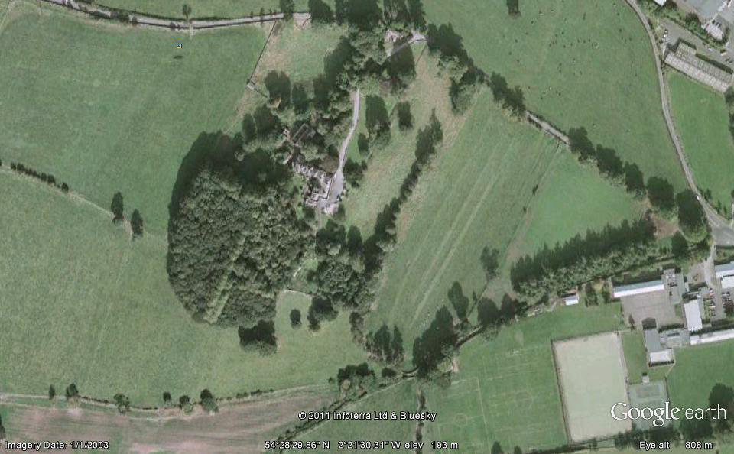
B
Registration and results
NORTHERN SCHOOLS INTER COUNTY XC MATCH
on
SAT 4th FEB. 2017
NOON
at
KIRKBY STEPHEN
GRAMMAR SCHOOL
FOOD
C
E
F
FINISH
START
Small lap
600m
Full lap
1900m
Medium Lap
1400m
D
Toilets

A

TIMETABLE AND COURSE INFORMATION
NOON Minor Girls: 1 Full lap (1900m) - ABCDEF-finish 12.15pm Minor Boys and 12.30am Junior Girls: 1 Small lap + 1 Large lap (2500m approx.) – ABA + BCDEF-finish

12.50am Junior Boys: and 13.10pm Senior Girls: 13.30pm Inter Girls: 2 Full laps (3800m approx.) – ABCDEF + ABCDEF-finish THE FULL & MEDIUM LAPS
INCOPORATE THE SMALL LAP
13.55pm Inter Boys: 3 Full laps (5700m approx.) ABCDEF + ABCDEF + ABCDEF-finish

14.20pm Senior Boys: 1 Medium l Lap + 3 Full laps: (7100m approx.) – ABCD-F +ABCDEF + ABCDEF + ABCDEF-finish

ALL COURSES & TIMES ARE PROVISIONAL AND ARE SUBJECT TO CHANGE

