





Northern Schools Inter County
Cross-country Championships 2026

Akay Pavilion, Sedbergh School
Saturday 7th February 2026


Time | Races | Distance
10:30 | Course open for inspection
12:00 | Course closed
12:30 | Minor Girls Race (Yr7) | 2.8 km – 70m ascent  (1 long lap)
12:45 | Minor Boys Race (Yr7) | 2.8 km – 70m ascent  (1 long lap)
13:00 | Junior Girls Race (Yr 8/9) | 3.4 km – 62m ascent  (2 medium laps)
13:20 | Junior Boys Race (Yr 8/9) | 3.4 km – 62m ascent  (2 medium laps)
13:45 | Intermediate Girls Race (Yr 10/11) | 4.5 km – 101m ascent  (1 medium & 1 long lap)
14:00  Before Girls finish | Intermediate Boys Race (Yr 10/11) | 5.6 km – 142m ascent  (2 long laps)
14:30 | Senior Girls Race (Yr 12/13) | 5.6 km – 140m ascent  (2 long laps)
14:45  Before Girls finish | Senior Boys Race (Yr 12/13) | 7.3 km – 171m ascent  (1 medium & 2 long laps)

All race times are approximate
Please report for your race at least 5 mins before the start time.
Event Organiser: Richard Wells 07999 534155
Event Referee: John Driscoll 07974 015751
Sedbergh XC Course (Medium Lap 1.7km – 31m ascent)
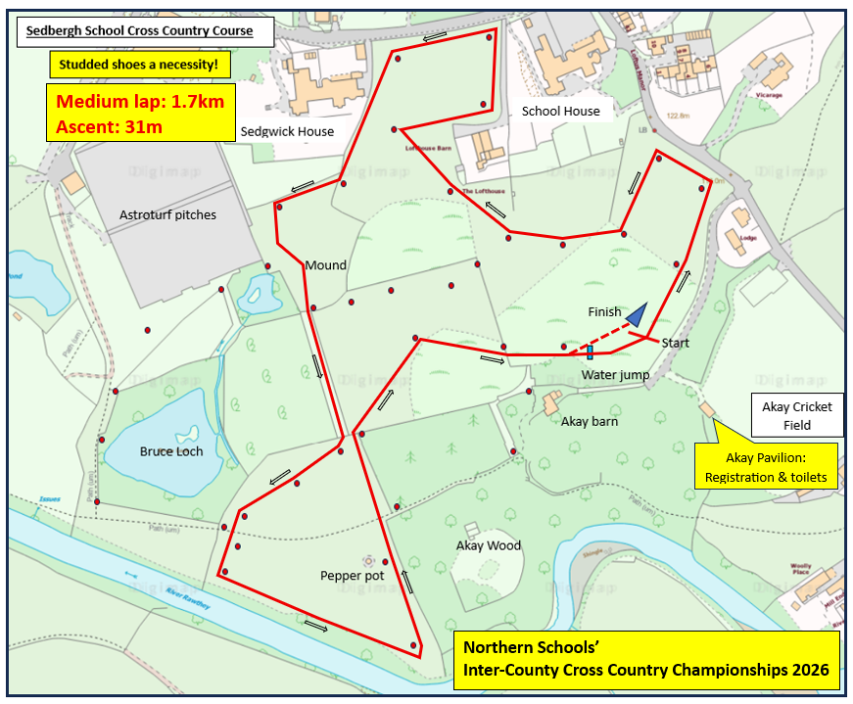
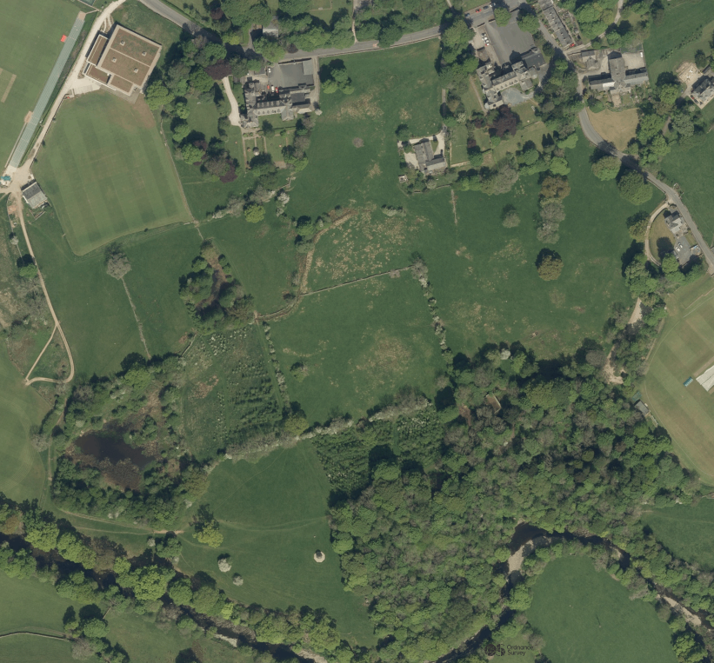
Akay Pavilion
Registration and Adult toilets
Entrance to XC Course
Water jump
Busk Lane
Please
keep off
FinishStart
Start
Sedbergh XC Course (Long Lap 2.8km – 70m ascent)
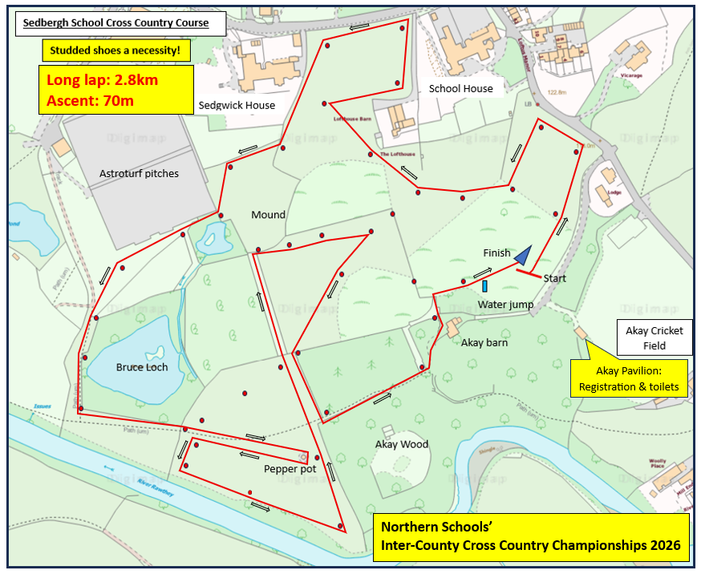
Water jump
FinishStart
Akay Pavilion
Registration and Toilets
Entrance to XC Course
Start
Please
keep off
Busk Lane

